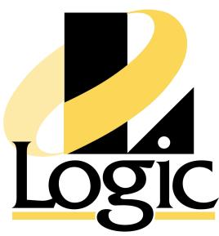

Purchasing/Order Processing Clerk Position November 2014

The Company
Logic, Inc. is a privately-owned Kansas City-based distributor of industrial automation products
typically used by utilities and manufacturing. We sell and support a variety of products including programmable controllers, operator interface hardware and software, industrial computers, variable frequency drives, software used in manufacturing, and precision motion control products. Our corporate headquarters is in Olathe, Kansas with sales offices in Wichita, KS, St. Louis, MO, Springfield, MO and Omaha, NE.

The Position – Purchasing/Order Processing Clerk
This position coordinates sales orders, inventory, and vendor purchase orders to meet our
customer’s expectations. Duties include handling industrial hardware and software from a multitude of vendor sites as well as entering purchase orders and customer orders in Microsoft Dynamics Great Plains. It is also involved in expediting orders, interfacing with vendors, customers and sales staff to resolve day to day issues of pricing, delivery and other customer related issues along with processing repairs and returns.

Requirements
• Strong organizational skills – The position requires the ability to track, accomplish, and
prioritize a large number of tasks.

• Degree – You must have graduated from an accredited university with a degree in business or a 2-year business program.

• Data Entry & Analysis – Computer experience is essential. A strong working knowledge of Microsoft Office is needed and experience with an accounting program would be very helpful.

• Fast Learner– This position will need to learn to negotiate new vendor and new customer sites, as well as our updated internal software.

• Strong Communicator– You will need to explain situations both verbally and written in a way that people clearly understand what you are trying to convey.

• People Person– To be successful you must enjoy working with many different types of people. This job may require you to be more outgoing than your natural inclination.

• Team Player– Everyone within Logic, Inc. is working towards a common goal.

• Self-Manage– We do not micro-manage your work life; you must be able to manage time effectively, organize your material, and perform quality work without anyone looking over

your shoulder.

• Positive Attitude– This role requires a personality that is generally positive and enjoyable.
This is required for effectively interfacing with coworkers, customers, and vendors.

• Mediator– As a distributor, our role is to advocate for the customers to the vendors and to advocate for the vendor to customers. This requires an objective perspective. General care must be taken when you feel that a customer or vendor is being illogical or irrational, and it is important not to try and change a closely-held belief of either party.

Compensation will be commensurate with education and experience. Send resume: resumes@logic-control.com

